Dependency Parser

The EU-Ukraine Free Trade deal officially comes into force

Dep Parse: [('ROOT', 0, 5), ('det', 4, 1), ('compound', 4, 2), ('compound', 4, 3), ('nsubj', 5, 4), ('advmod', 5, 6), ('dobj', 5, 7), ('case', 9, 8), ('nmod', 7, 9)]

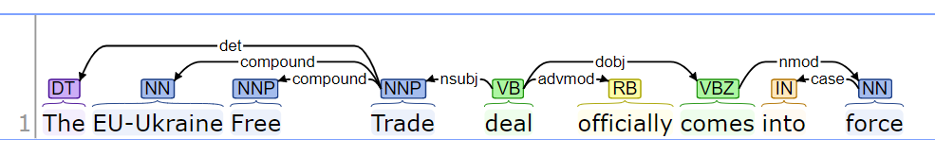

**Det**= determiner (A determiner is the relation between the head of an NP and its determiner.)

**Compound**=

**Nsub**= nominal subject A nominal subject is a noun phrase which is the syntactic subject of a clause. The governor of this relation might not always be a verb: when the verb is a copular verb, the root of the clause is the complement of the copular verb, which can be an adjective or noun.

“Clinton defeated Dole” nsubj(defeated, Clinton)

“The baby is cute” nsubj(cute, baby)

**Advmod=** adverb modifier An adverb modifier of a word is a (non-clausal) adverb or adverb-headed phrase that serves to modify the meaning of the word.

“Genetically modified food” advmod(modified, genetically)

“less often” advmod(often, less)